Solve Me First

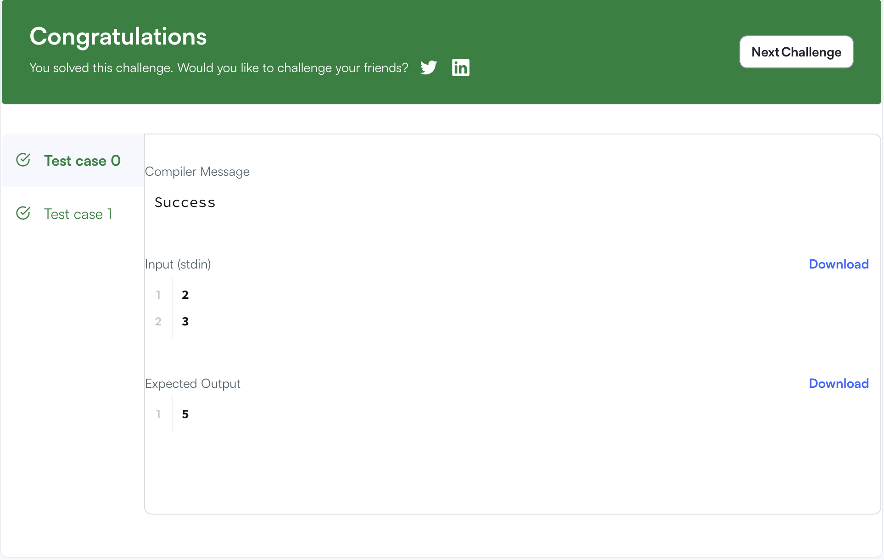
Code:
#include <stdio.h>
#include <string.h>
#include <math.h>
#include <stdlib.h>
int solveMeFirst(int a, int b) {
return a + b;
}
int main() {
int num1, num2;
scanf("%d %d", &num1, &num2);
int sum;
sum = solveMeFirst(num1, num2);
printf("%d", sum);
return 0;
}

